**Skill-End Project**

**Setting up a Database for a Security Agency Using MongoDB**

**Project Agenda:** To create a MongoDB Atlas account, design the database using a NoSQL approach, and perform CRUD operations

**Tools required:** Python SDK, MongoDB Compass (Optional), and PyMongo library

**Prerequisites:** Python 3.8 SDK must be installed on the system

Steps to be followed:

1. Setting up the MongoDB Atlas Cluster
2. Defining classes that represent documents
3. Creating functions for database connection and CRUD operations
4. Creating a main function to read data from the user
5. Executing the project

**Step 1:** **Setting up the MongoDB Atlas Cluster**

1. Navigate to the URL **https://account.mongodb.com/account/login** and create an account with MongoDB.

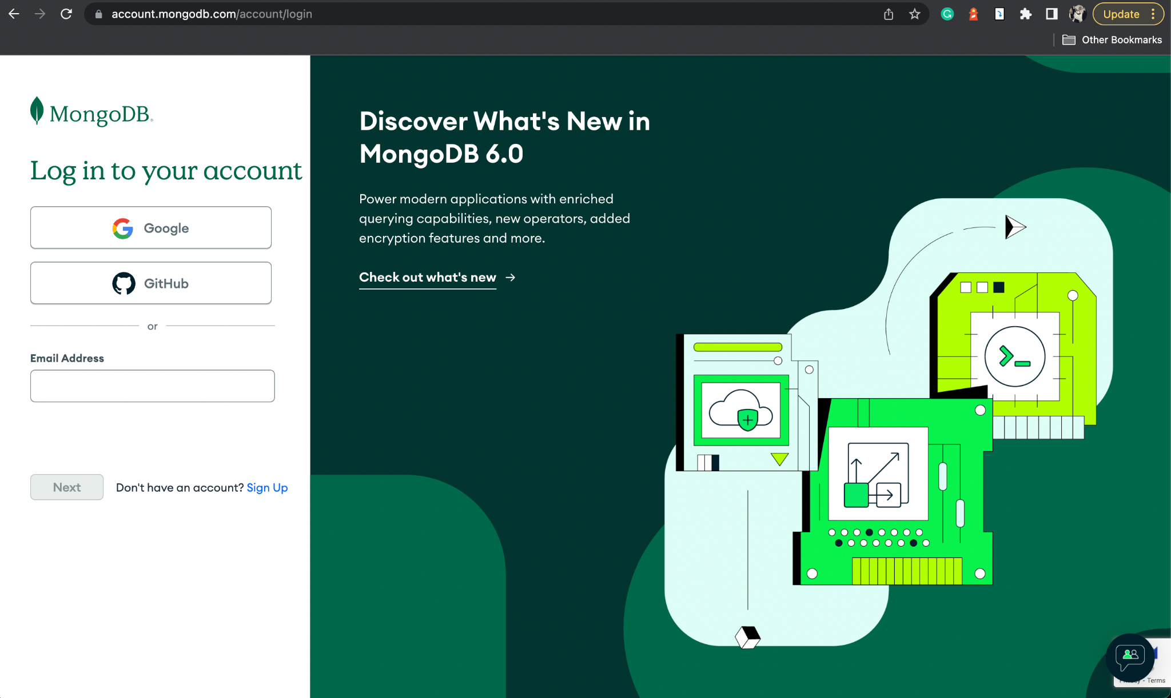

1. After creating the account, go to the MongoDB home page and create an organization.

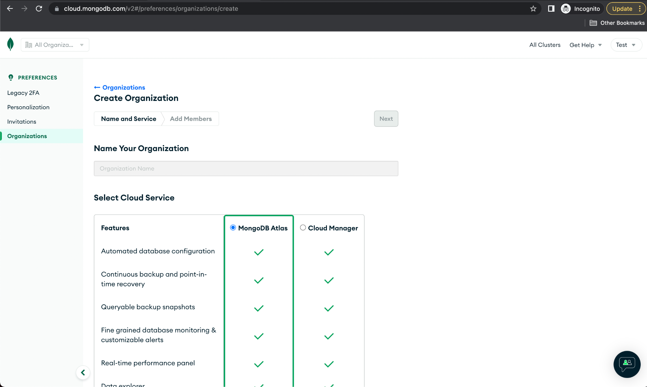

1. Then, within the organization, create a new project.

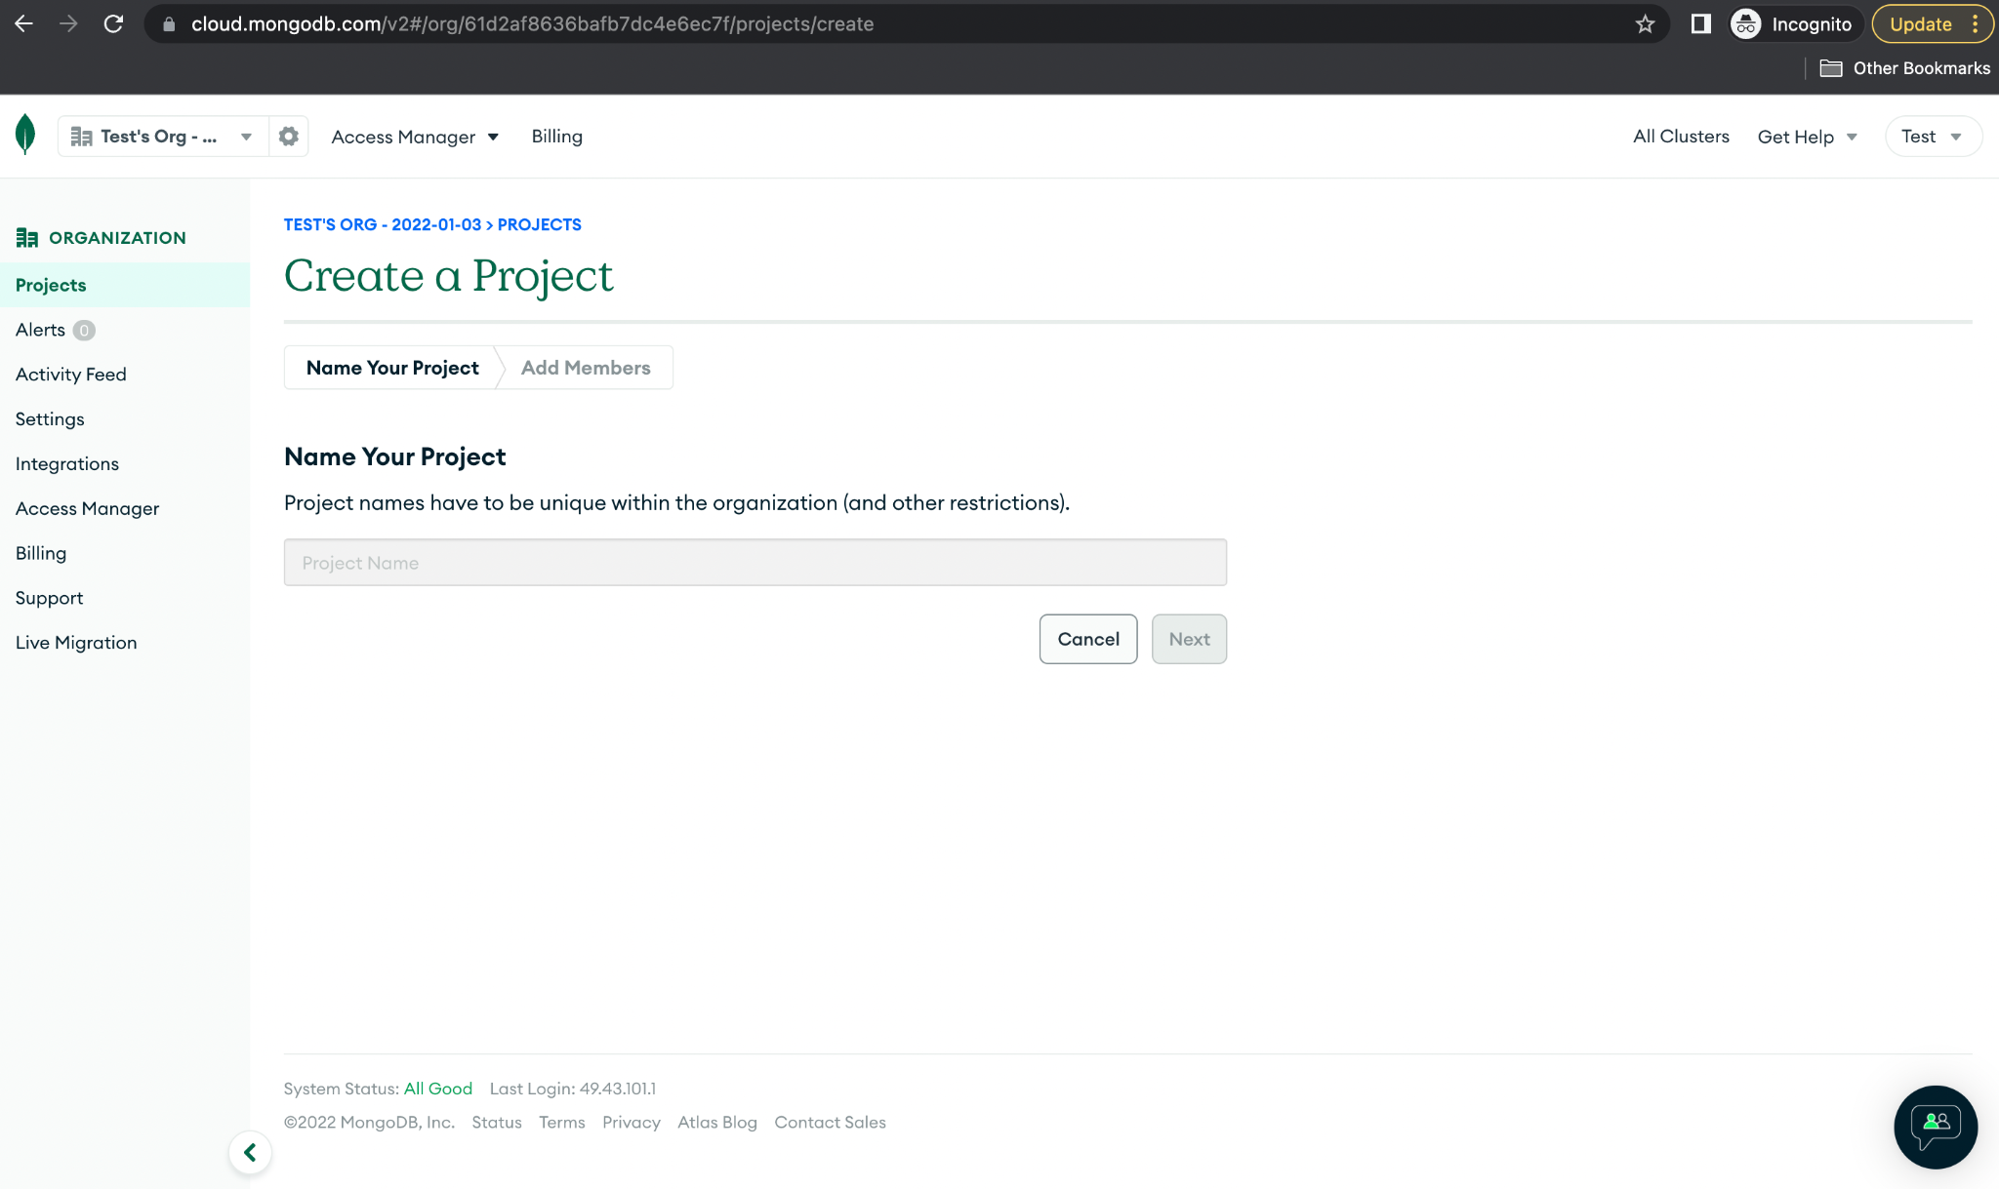

1. After Navigate to the Database section and select **Build a Database** within the previously created project.

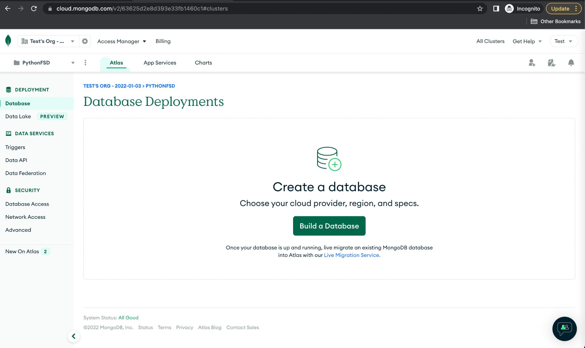

1. Choose the free tier eligible option to create a MongoDB in a shared cloud environment.

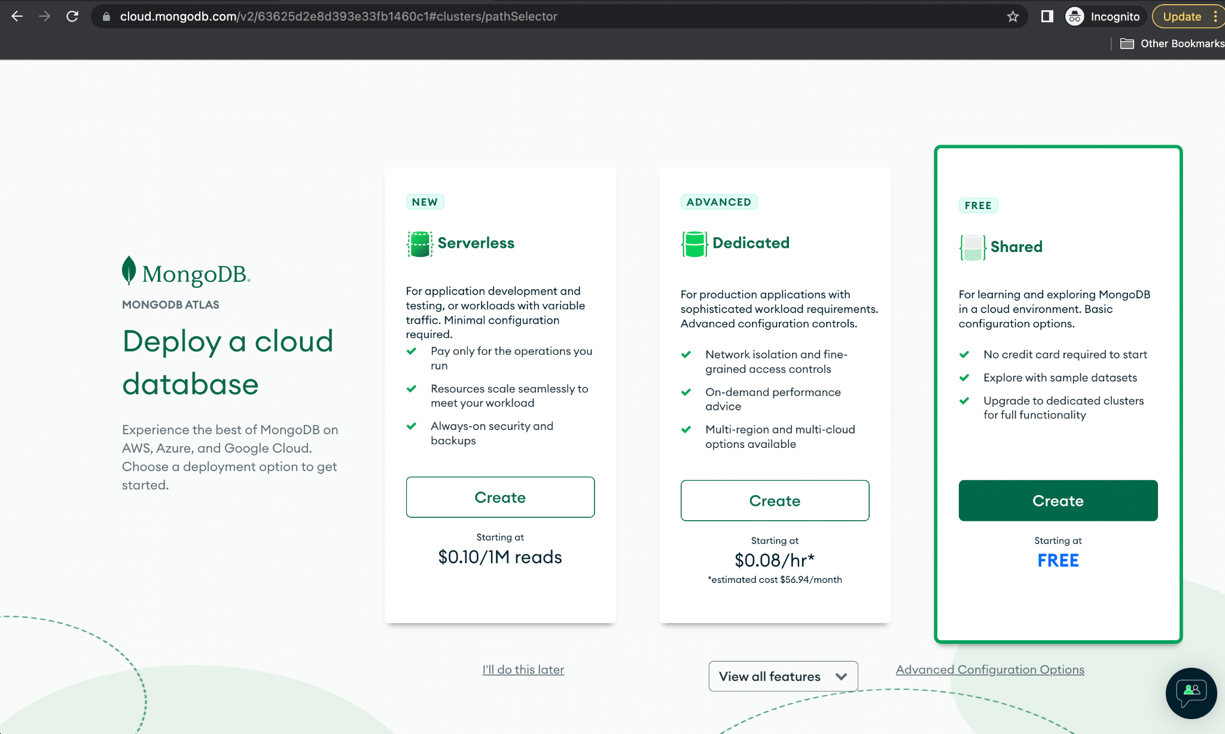

1. Select **AWS** as the cloud provider.

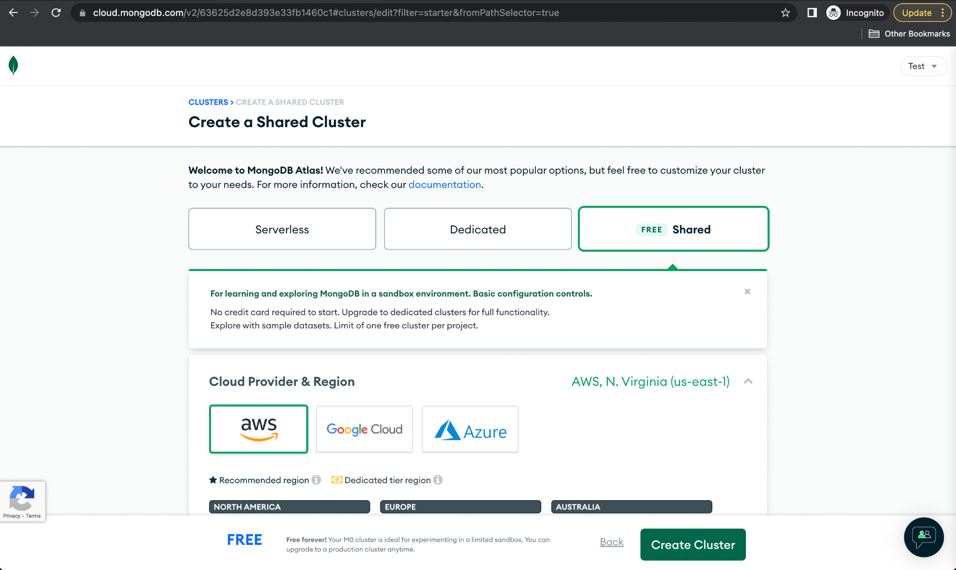

1. After Choose the region based on the closest geographical boundaries, then click on **Create Cluster**.

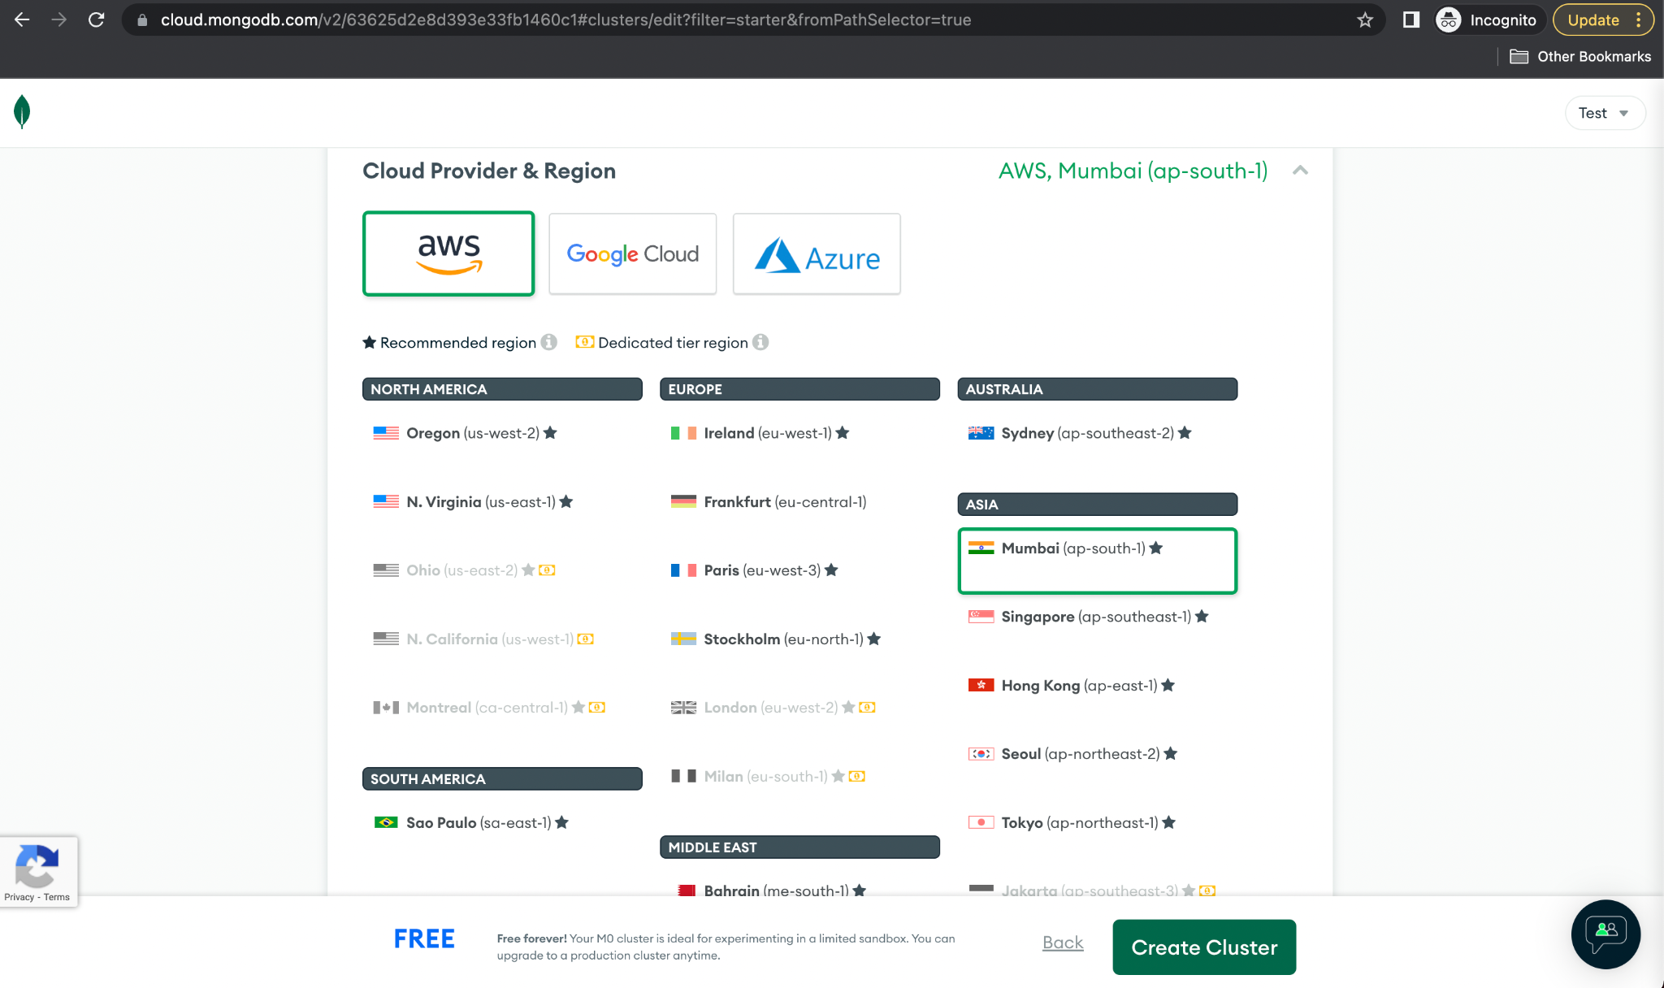

1. MongoDB Atlas Cluster creation is currently in progress. In the meantime, we can set up security for the project.

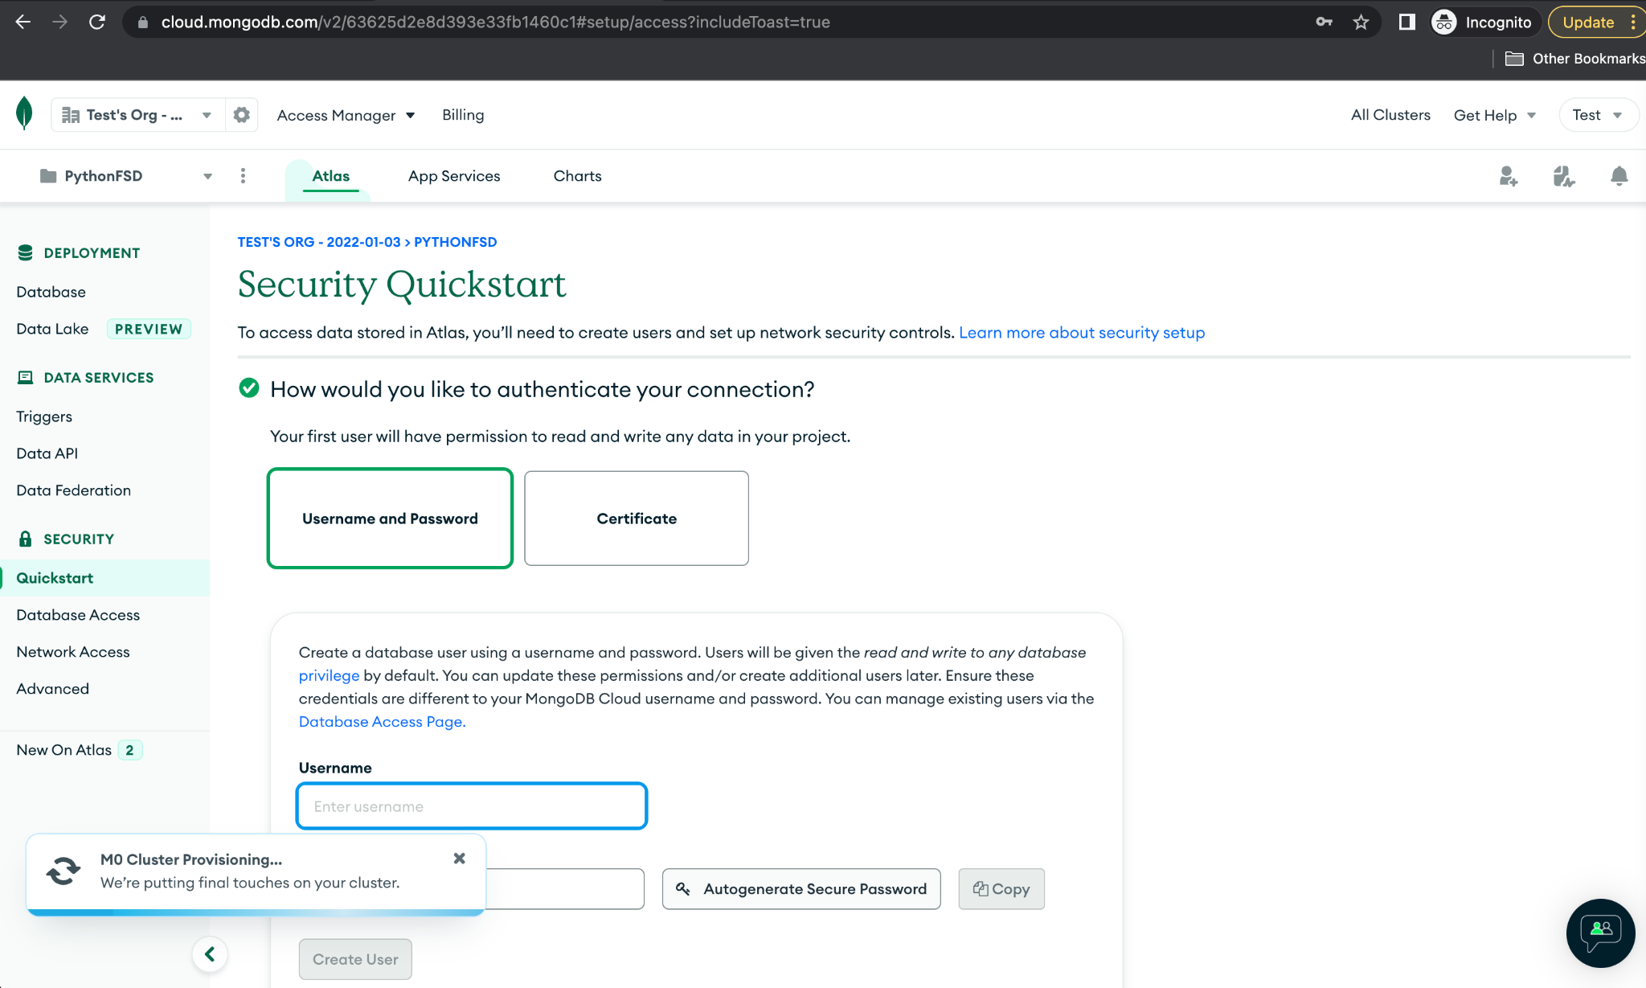

1. Configure the username and password for the MongoDB Atlas cluster from **Quickstart** security; this will be used to connect to the database later from the Python project.

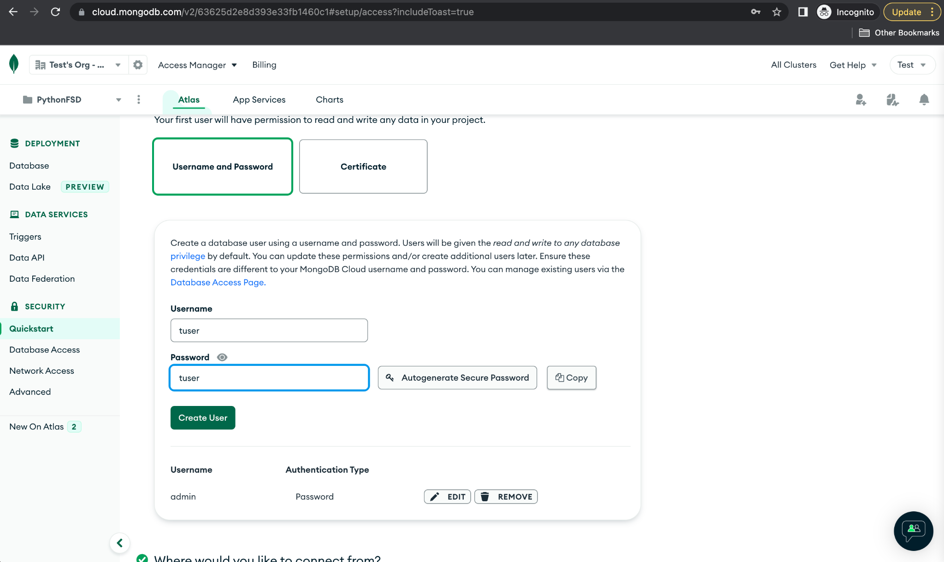

1. Now, add the entry to the IP list as **0.0.0.0/0** so that we can connect to MongoDB Atlas from anywhere.

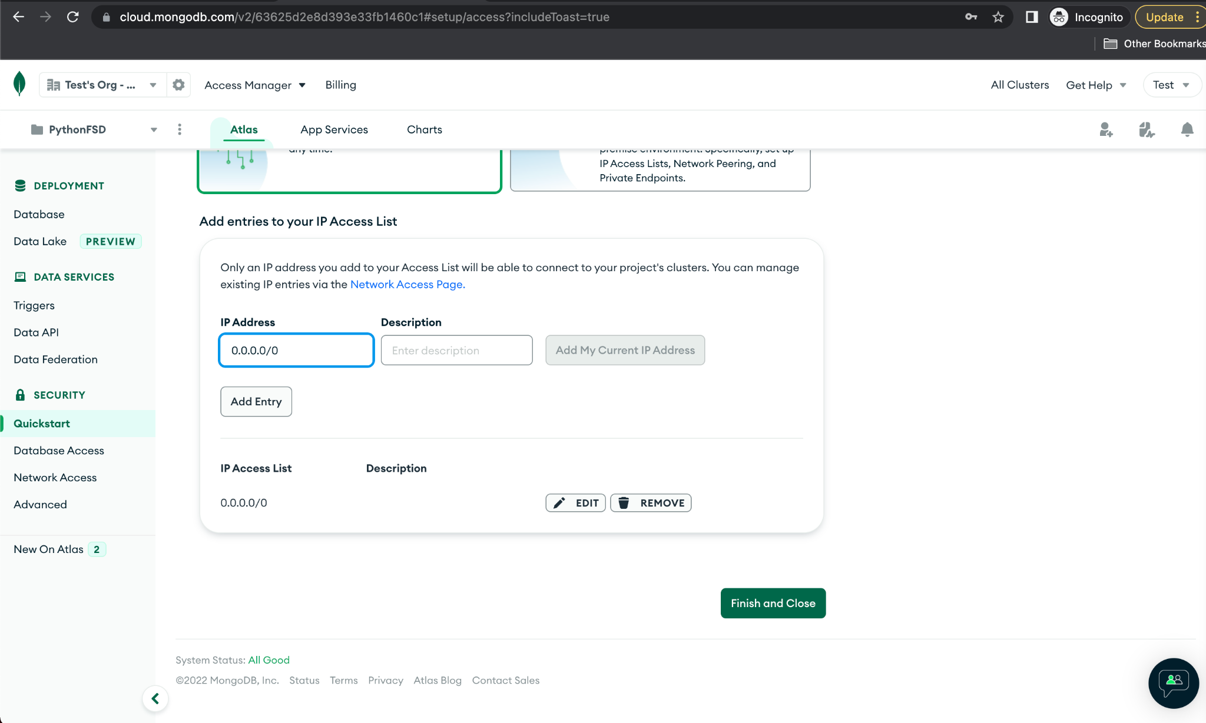

1. Once the security configuration is complete, users will receive a congratulations message and can proceed to the database page.

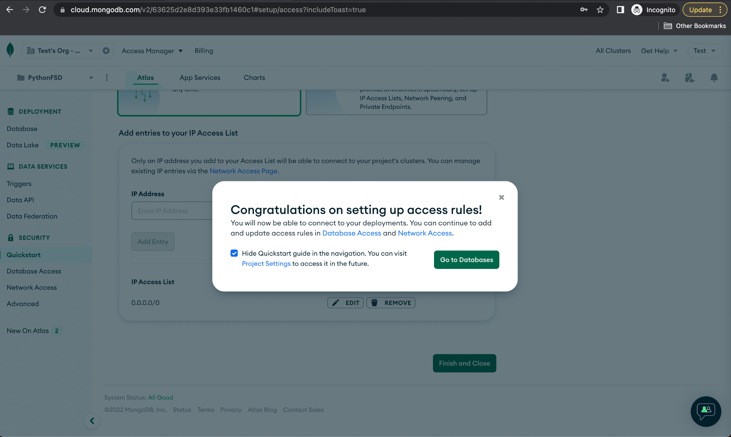

1. **Cluster0** is now available for use. Click on **Browse Collections** to view databases and collections in MongoDB.

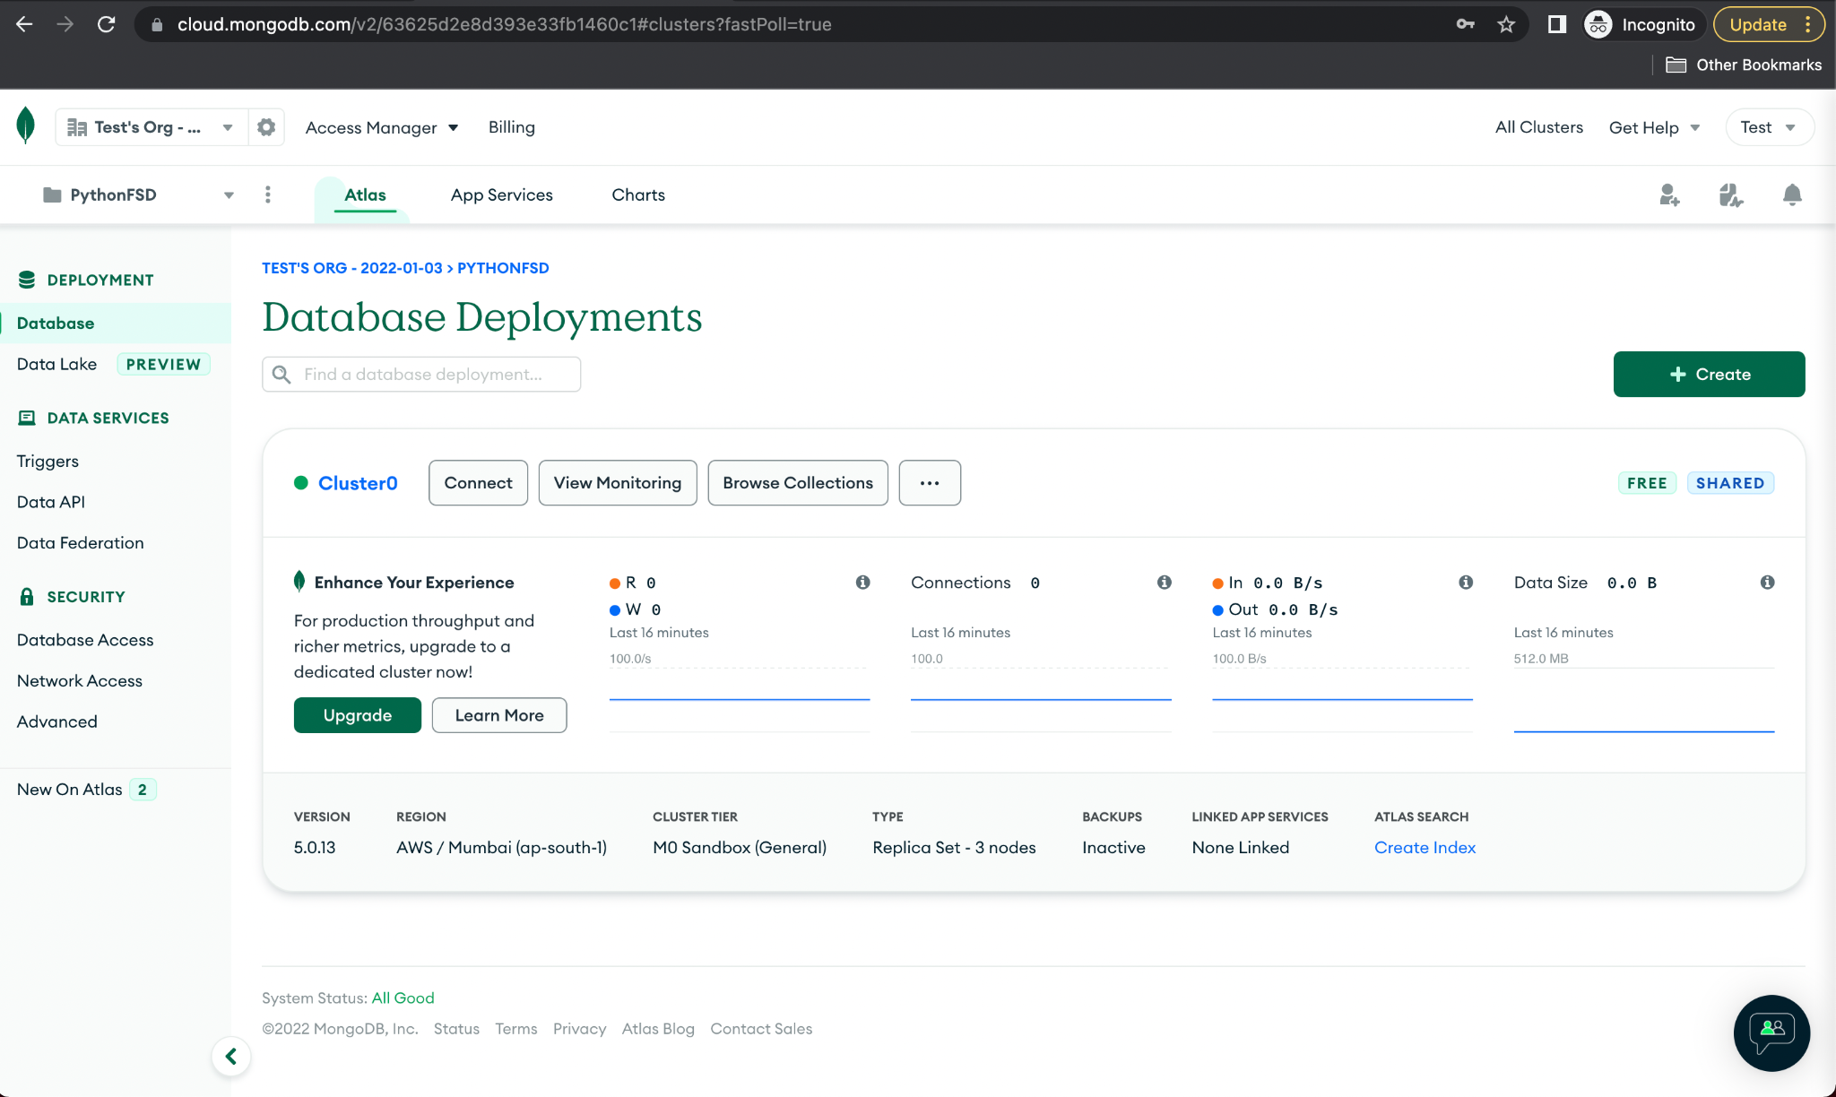

**Step 2:** **Defining classes that represent documents**

The structure of model classes using OOPS is as follows:

1. **Client** class represents the customers for Darwin security agency.

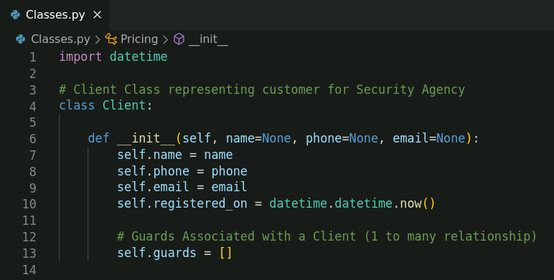

1. **Pricing** class for charges for a security guard.

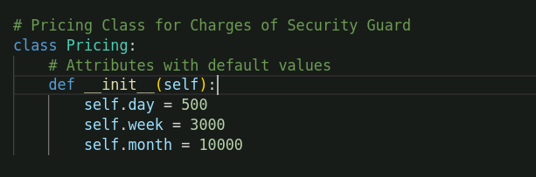

1. **SecurityGuard** class represents a security guard and their charges.

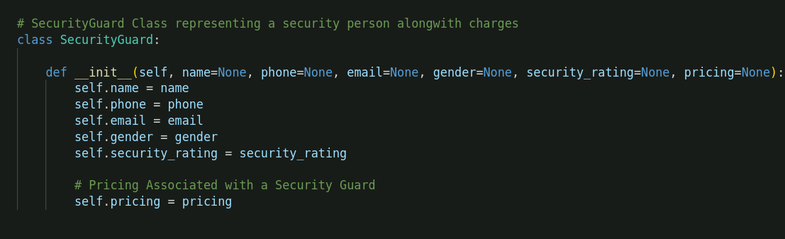

1. **ServiceRequest** class represents a client's request and has response options with status management.

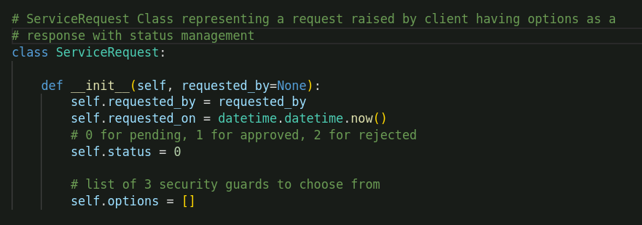

|  |
| --- |
| **Note:** Create all the model classes in a **classes.py** file or any other name of your choice |

**Step 3:** **Creating functions for database connection and CRUD operations**

1. Create a new directory named **DarwinAgency** and navigate within it.

**mkdir** **DarwinAgency**

**cd DarwinAgency/**

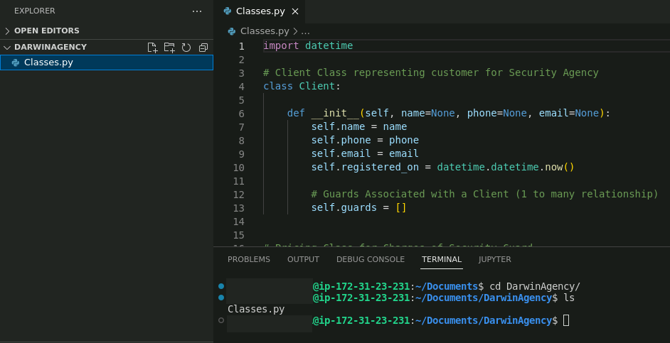

|  |
| --- |
| **Note:** Include the **classes.py** file in the same directory |

1. Install the **PyMongo** library by executing the command on the terminal:

**pip install pymongo**

To verify the installation and version, use the command: **pip freeze | grep pymongo**



1. Now, create a python file named **DB.py** and write code to connect to DB.

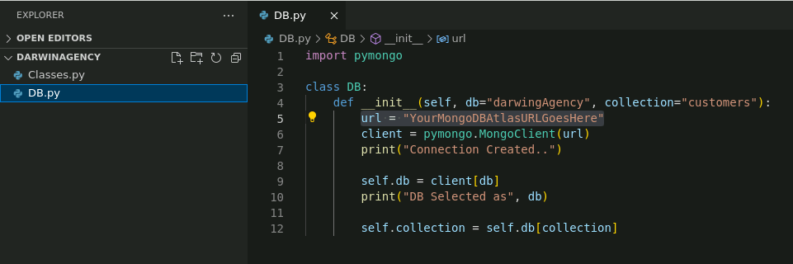

To find the URL to connect to the Cluster, navigate to the MongoDB home page, choose the database, and click **Connect** to establish a connection from a Python application.

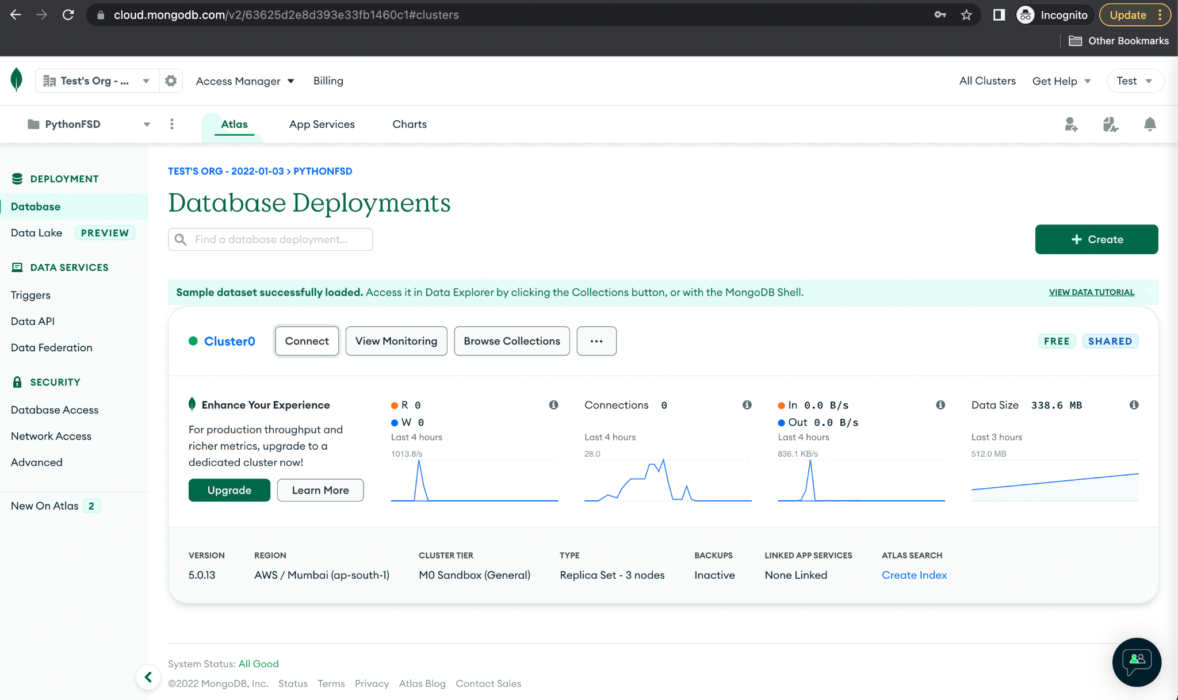

Then, select the option **Connect your application**.

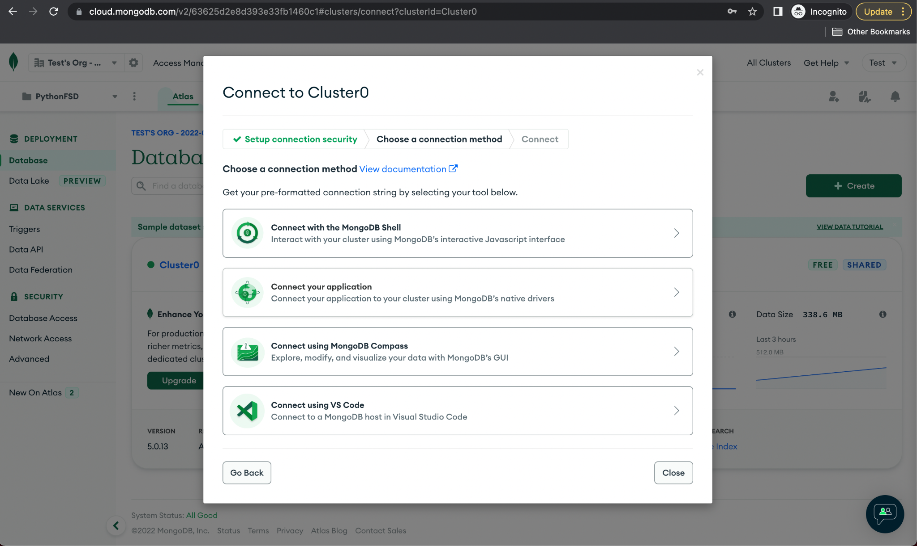

Select the driver as **Python** with the appropriate version and copy the URL displayed on the screen.

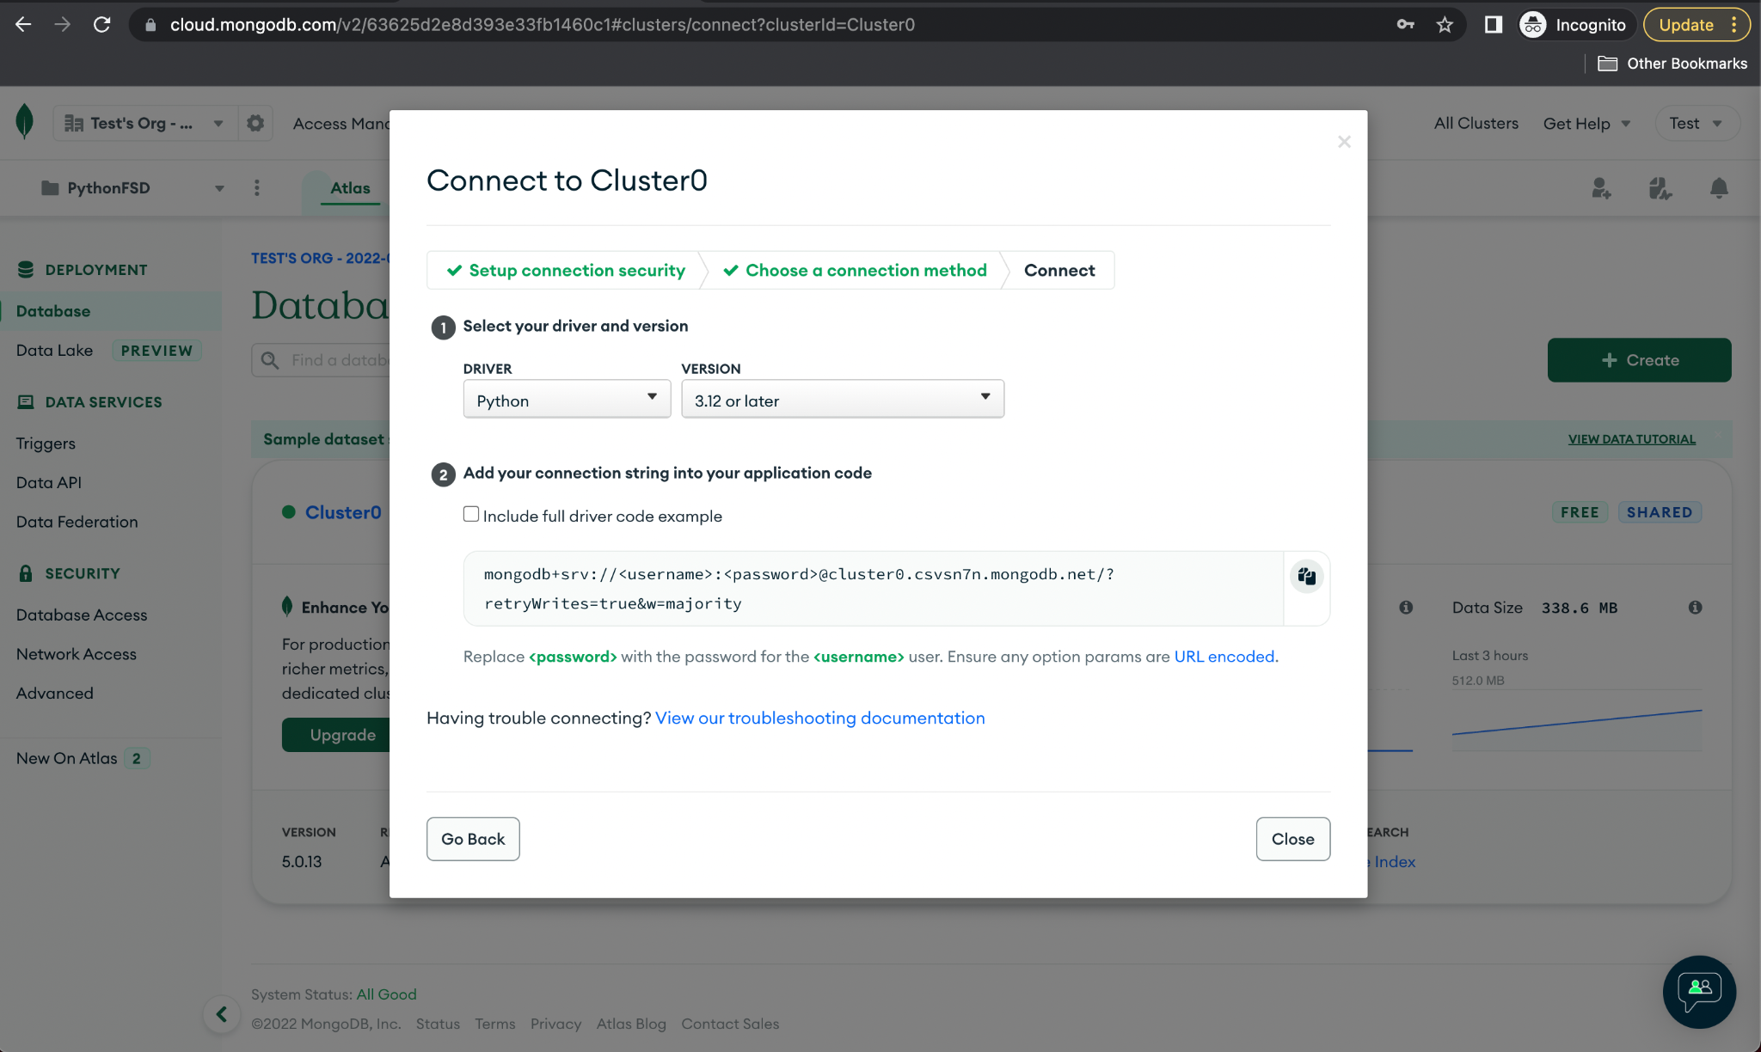

|  |
| --- |
| **Note:** The URL must be updated with the username and password that were used while setting up MongoDB Atlas. |

1. Next, create the following functions in the DB.py file to perform CRUD operations on security guards:
   * 1. **Insert:**

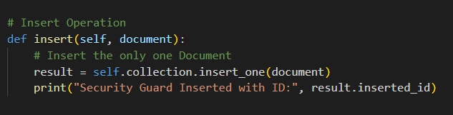

* + 1. **Query:**

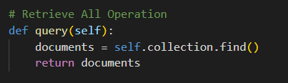

* + 1. **Update:**

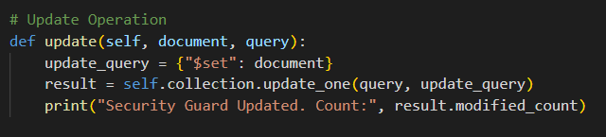

* + 1. **Delete:**

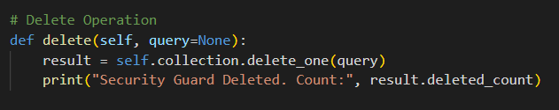

**Step 4:** **Creating a main function to read data from the user**

1. Inside the **DarwinAgency** folder, create a new file **App.py** to add a main function.
2. Add the following code to the file, which will run a loop and ask the user for various inputs:

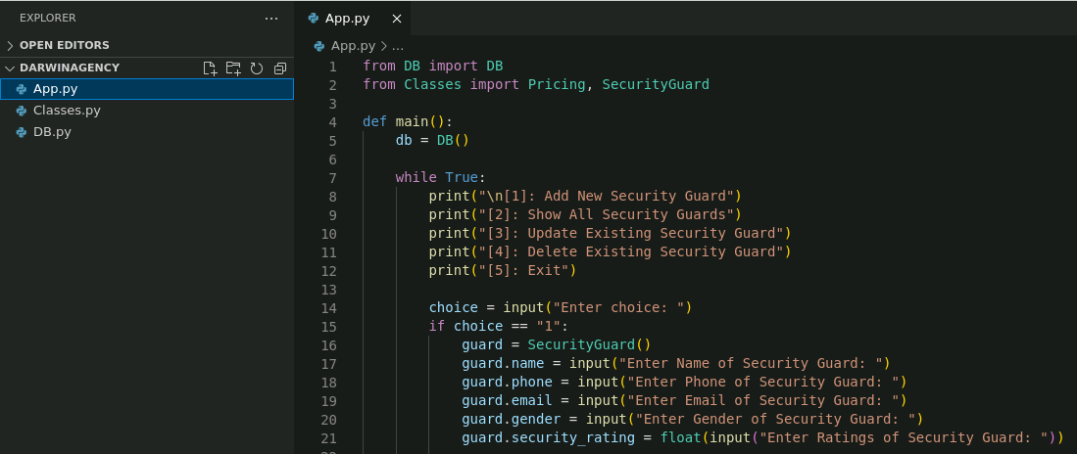

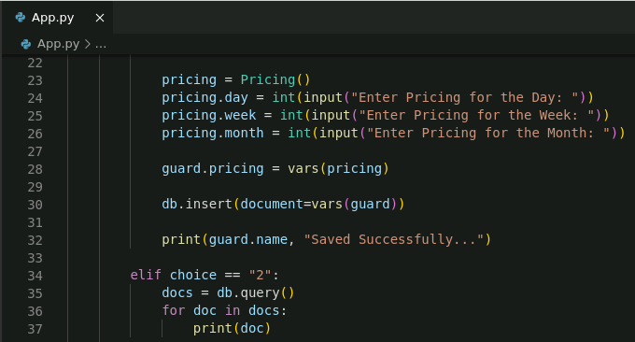

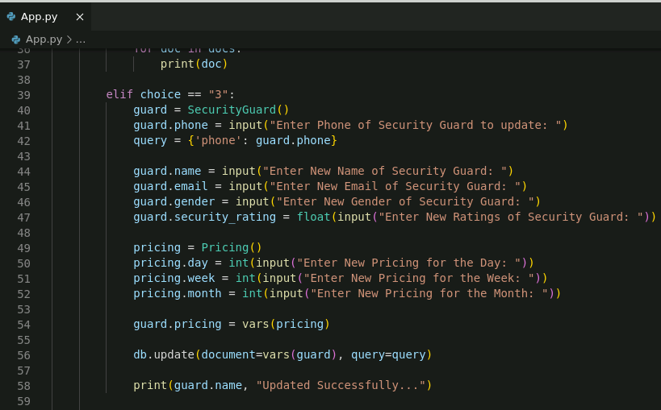

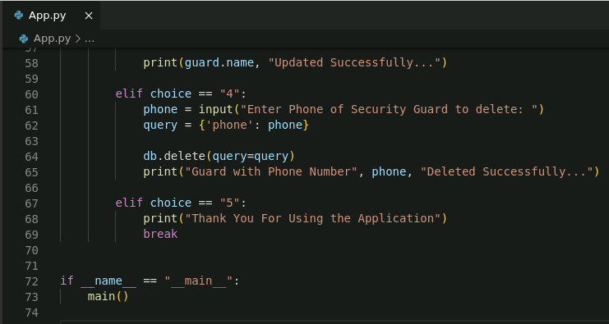

1. Select the Python interpreter with version **3.8** from the VS code command palette using the shortcut **Ctrl + shift + P**.

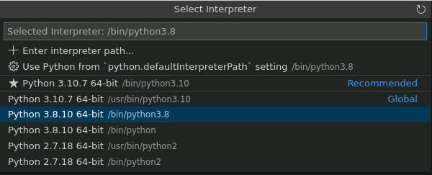

1. Run the **App.js** file and validate the CRUD operations by following the options on the console.

**python App.js**

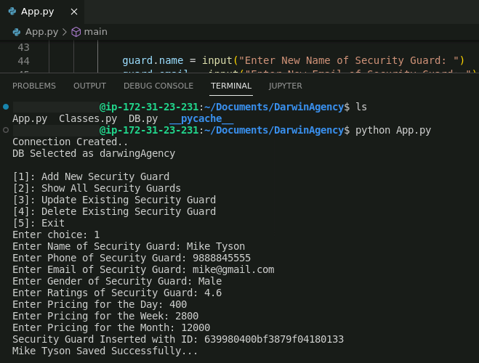

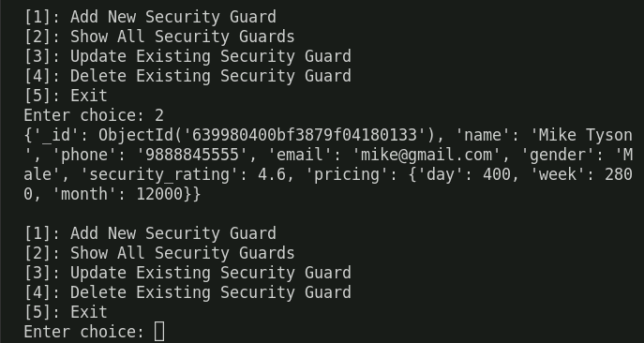

In the screenshots above, you can see that we successfully added a security guard and retrieved it from the console; the same can be verified from the MongoDB Atlas dashboard.

